Checking radio buttons

Checking radio buttons on a form is a little tricky. You have to loop through each button, testing for a value of checked, which means it was selected. Only one radio button in a group can be selected, so if you find a value of checked you can break out of the loop.

If no radio button was checked then you display a message stating this. If any one of them is checked then you can display the payment type. Here's the code for your radio button function:

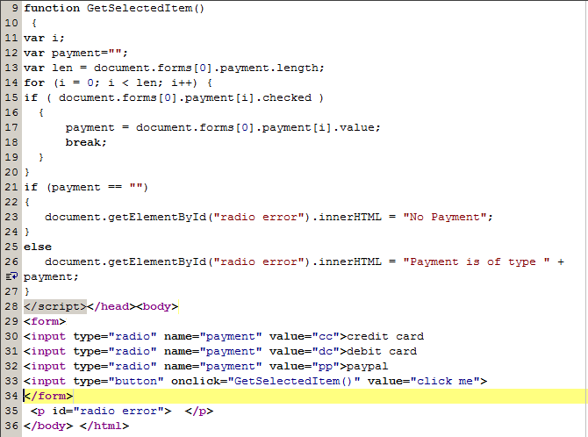

First we set up a variable called payment and set it to be a blank string. This will hold the value of the checked radio button, if the user has selected a radio button and will be empty otherwise. The next line is this:

var len = document.frmOne.payment.length;

On the right of the equal sign we again try to access a form element. This time, the element we want has a name of payment. This came from the HTML:

<input type="radio" name="payment" value="cc">credit card  
<input type="radio" name="payment" value="dc">debit card  
<input type="radio" name="payment" value="pp">paypal

If you want to group radio buttons together you give them the same name. You can then access this name in your code. But look at what is now on the end:

document.frmOne.payment.length;

Length is how many radio button are in the group. We can use this length in the loop:

for (i = 0; i < len; i++) {

if ( document.frmOne.payment[i].checked ) {

payment = document.frmOne.payment[i].value;  
break;

}

}

The loop goes round and around while the variable called i is less than the length of the radio buttons. Inside of the loop we have this:

if ( document.frmOne.payment[i].checked ) {

payment = document.frmOne.payment[i].value;  
break;

}

This IF statements checks each radio button for a value of checked. But we can't just say:

document.frmOne.payment.checked

The payment part refers to the whole group of radio buttons. To get at each individual radio button you can use a pair of square brackets. Inside the square brackets you type a number. The number corresponds to a particular button. So payment[0] is the first button, payment[1] is the second button, and so on. If the IF statement detects that any one of these buttons has been checked it puts that value into the payment variable:

payment = document.frmOne.payment[i].value;

We can then break out of the loop because we know that the user has selected a radio button.

The IF statement after the loop checks what's inside the variable called payment.

Check Box

You can have 1 or more checkboxes on a form. In this example we only have 1, so checking it is fairly straightforward. If you have more than checkbox, though, you do the testing in exactly the same way as for radio buttons.

But here's the code for the checkCheckbox function:

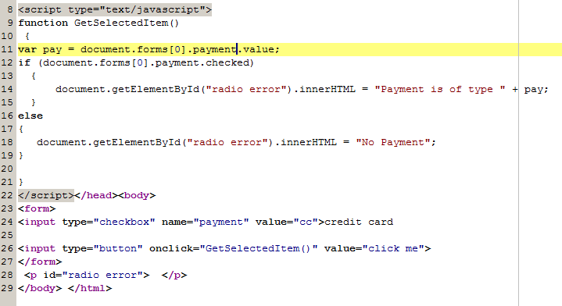

The IF statement just tests the payment element (a checkbox) for a value of checked. If it has been checked then we can display a message stating so and the payment type. If the checkbox has not been checked, the value will be "undefined" and we can display a message stating “No Payment”.

Note in the above example we have 1 checkbox therefore to get access to the value we can just say payment.value. If we had more than 1 check box we would have to use the array as in the radio example earlier i.e. payment[2] to get at the third check box.